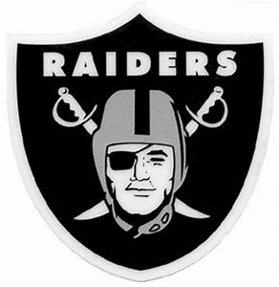
East Paulding Youth
Football & Cheer
<Date>

Hello <Company contact Name>,

Thank you for taking the time to consider sponsoring our <Grade> Team. This year marks our 7th Anniversary! We have grown so much, supporting youth from age 3 through 12 years. The organization is more than just playing football and cheering; it is building a community of support and friendship, helping our youth stay active and having an opportunity to give back.

We are so excited to help grow, mentor, train and develop our youth through our Football & Cheer Youth Program as part of the Cobb Football League. With the help of sponsors like you, together, we make this program a dream come true for our rising youth. Thank again for your consideration.

Sponsorship Requirements
There are three items needed from sponsors to have their logo included on our banners:
- Complete Sponsorship Form located on our website at www.eastpauldingyouthfootball.com
- Provide your payment for your Sponsorship Level to your grade’s Team Mom
- Please email a company logo digital file emailed to mamalone3827@gmail.com
  - IF possible, please send the logo file as:
    - vector (companylogo.esp) or High-Resolution PNG (companylogo.png)

Deadlines
All Sponsorships for logo placement on the banners, must be submitted and logo emailed to mamalone3827@gmail.com no later than September 1st, 2020.

If you have any questions or need assistance with the logos, please feel free to reach out to me at <your phone number> or email me at <your email>.

Thank you for your support and sponsorship!!! Let’s go Raiders!!!

Sincerely,

<Your Name>
<Grade> Team Mom

